SHERLOCK

Sherlock is a tool developed by Steve Troughton-Smith that is designed to help users find information about an app or tool by searching for it online. The tool allows users to search for a specific app or tool by name, and it will return information about the app or tool, including a description, website,developer, and other details.

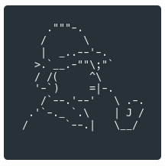

This link will take you to git hub :

<https://github.com/sherlock-project/sherlock>

[➪](https://coolsymbol.com/copy/Left-Shaded_White_Rightwards_Arrow_Symbol_%E2%9E%AA) Copy the code.

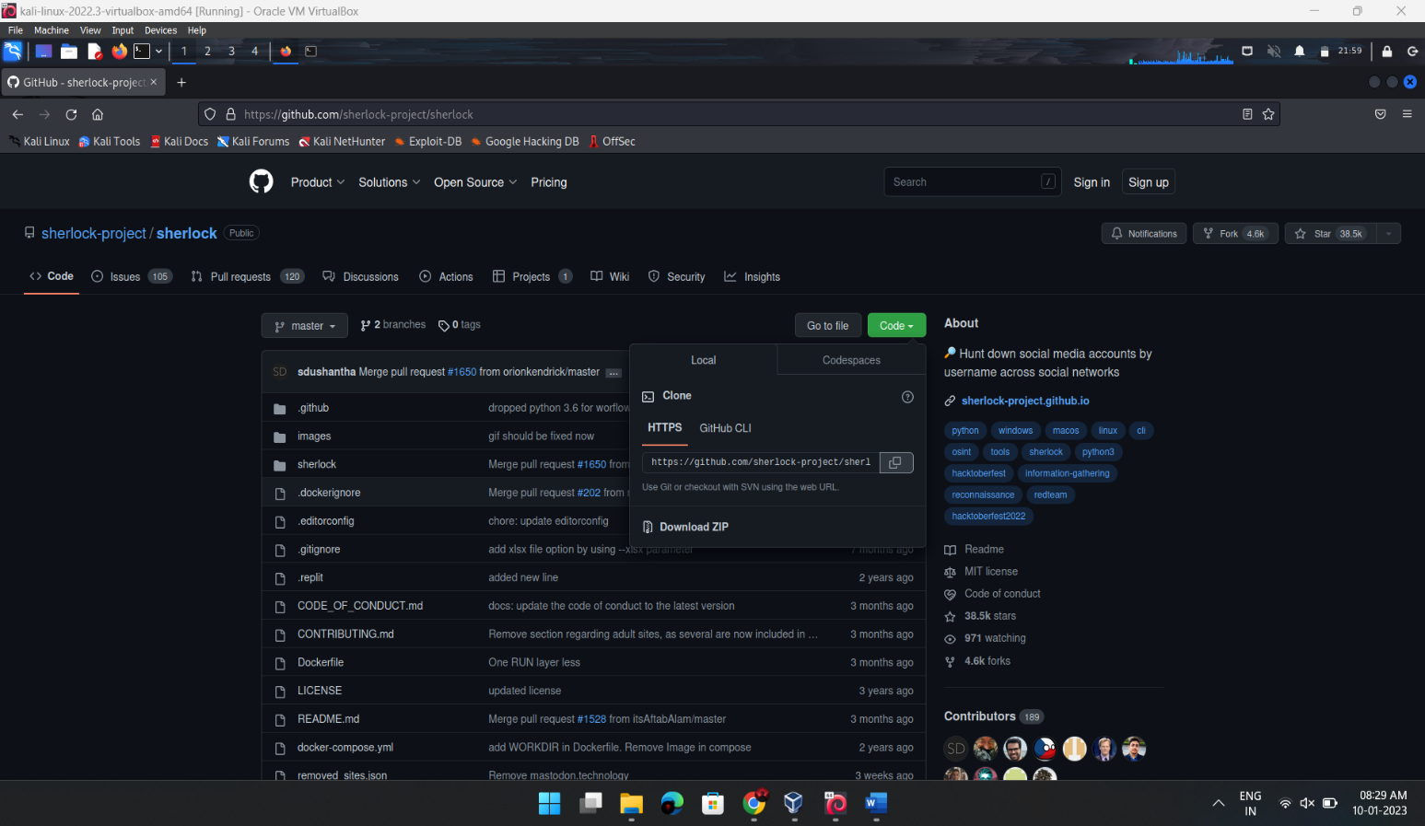

[➪](https://coolsymbol.com/copy/Left-Shaded_White_Rightwards_Arrow_Symbol_%E2%9E%AA) Open Terminal.

[➪](https://coolsymbol.com/copy/Left-Shaded_White_Rightwards_Arrow_Symbol_%E2%9E%AA) Type “git clone” & paste the code you had copied.

[➪](https://coolsymbol.com/copy/Left-Shaded_White_Rightwards_Arrow_Symbol_%E2%9E%AA) Press ENTER.

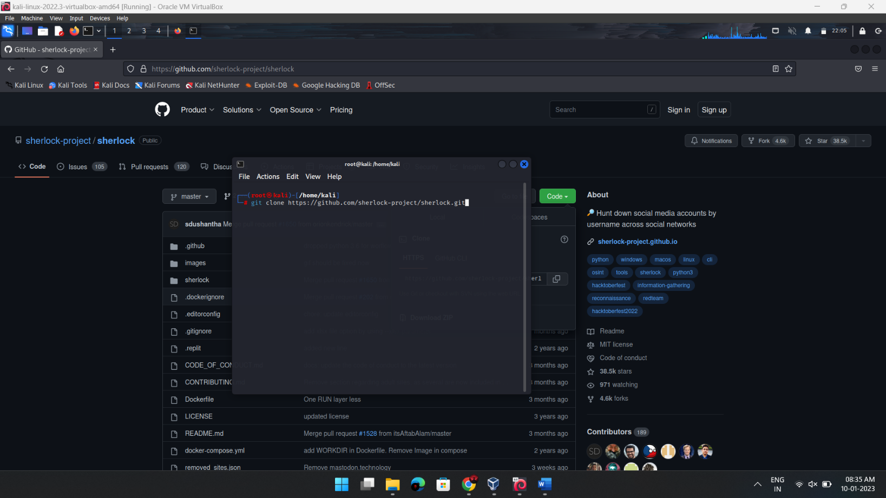

[➪](https://coolsymbol.com/copy/Left-Shaded_White_Rightwards_Arrow_Symbol_%E2%9E%AA) Then type “ls” .

[➪](https://coolsymbol.com/copy/Left-Shaded_White_Rightwards_Arrow_Symbol_%E2%9E%AA) Type “cd sherlock” .

[➪](https://coolsymbol.com/copy/Left-Shaded_White_Rightwards_Arrow_Symbol_%E2%9E%AA) Again type “ls”.

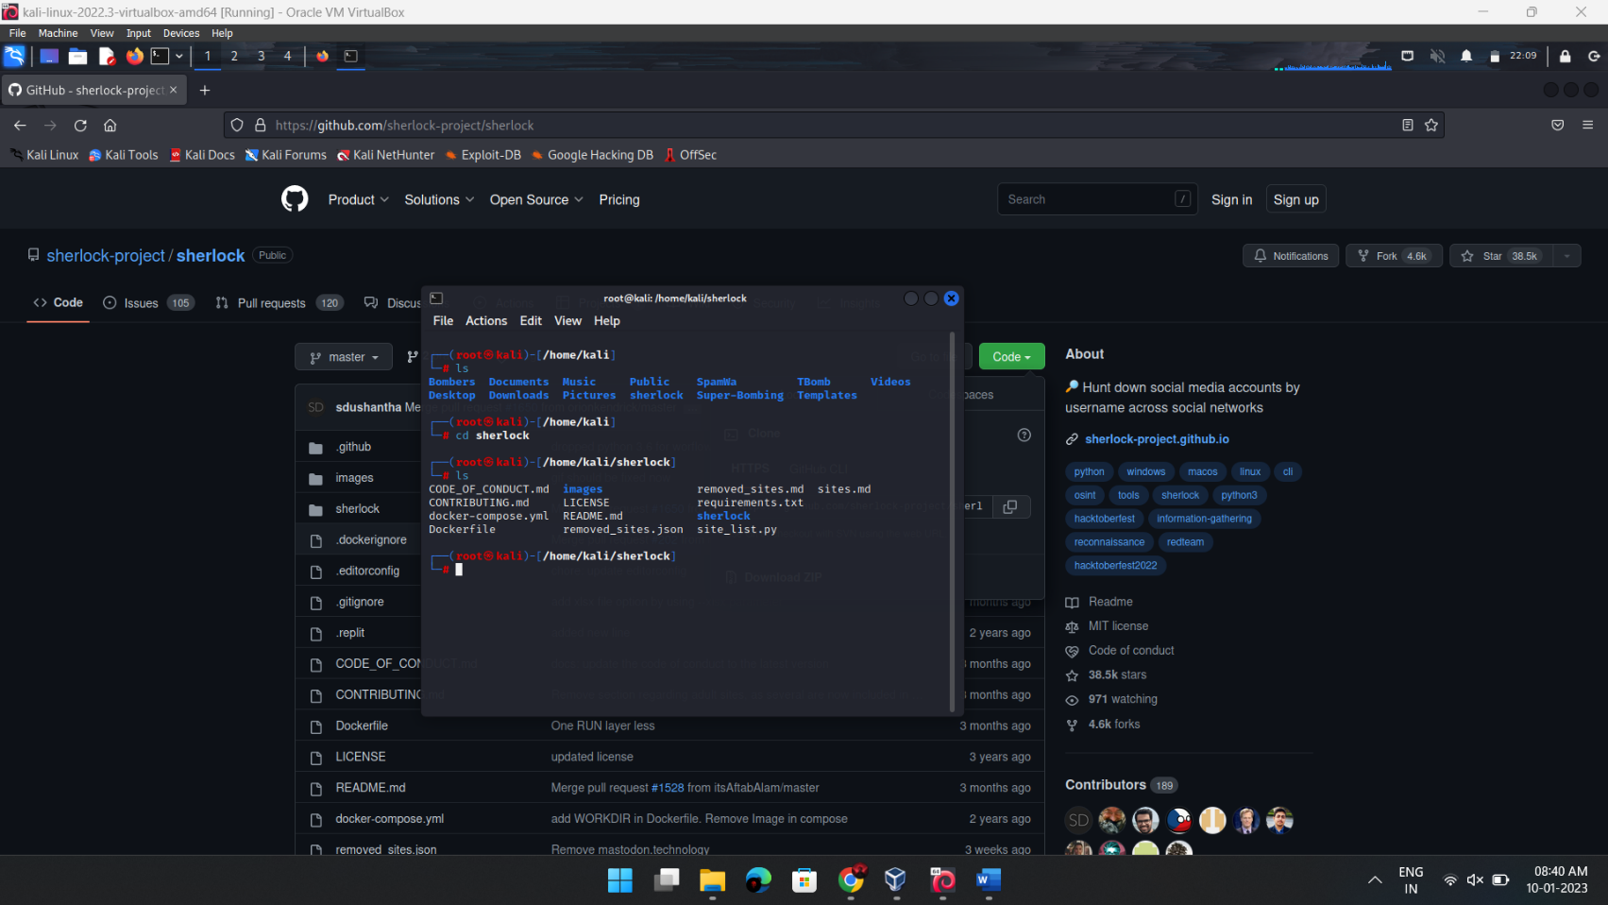

[➪](https://coolsymbol.com/copy/Left-Shaded_White_Rightwards_Arrow_Symbol_%E2%9E%AA) Now we need to install requirements.

[➪](https://coolsymbol.com/copy/Left-Shaded_White_Rightwards_Arrow_Symbol_%E2%9E%AA) So we need to type “python3 -m pip install -r requirements.txt”

[➪](https://coolsymbol.com/copy/Left-Shaded_White_Rightwards_Arrow_Symbol_%E2%9E%AA) OK, we have completed the installation.

[➪](https://coolsymbol.com/copy/Left-Shaded_White_Rightwards_Arrow_Symbol_%E2%9E%AA) For running sherlock type “python3 sherlock username”

[➪](https://coolsymbol.com/copy/Left-Shaded_White_Rightwards_Arrow_Symbol_%E2%9E%AA) Eg -: python3 sherlock dannyhaboi.

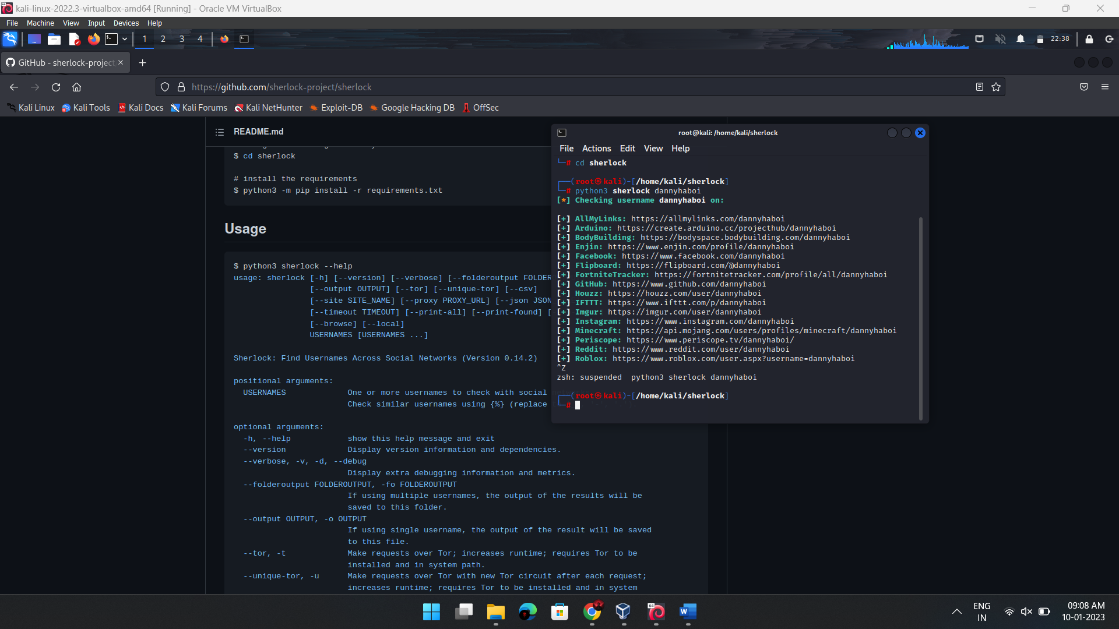

[➪](https://coolsymbol.com/copy/Left-Shaded_White_Rightwards_Arrow_Symbol_%E2%9E%AA) Here we go, we just got some results about dannyhaboi.

This is only for a educational poupous only..

Commands used :

# clone the repo

$ git clone https://github.com/sherlock-project/sherlock.git

# change the working directory to sherlock

$ cd sherlock

# install the requirements

$ python3 -m pip install -r requirements.txt